Image Captioning

***Wireframe Documentation***

**Home page**

1. This home page that should be available for the user.

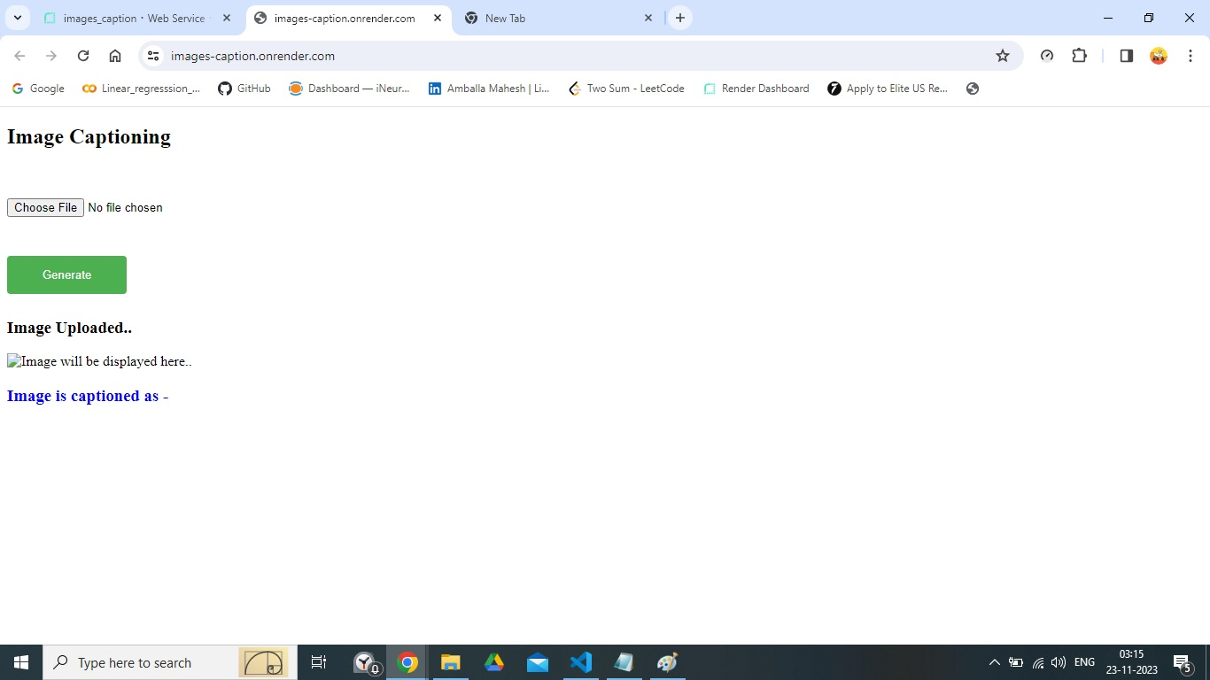

1. The user should get the output as below mentioned.

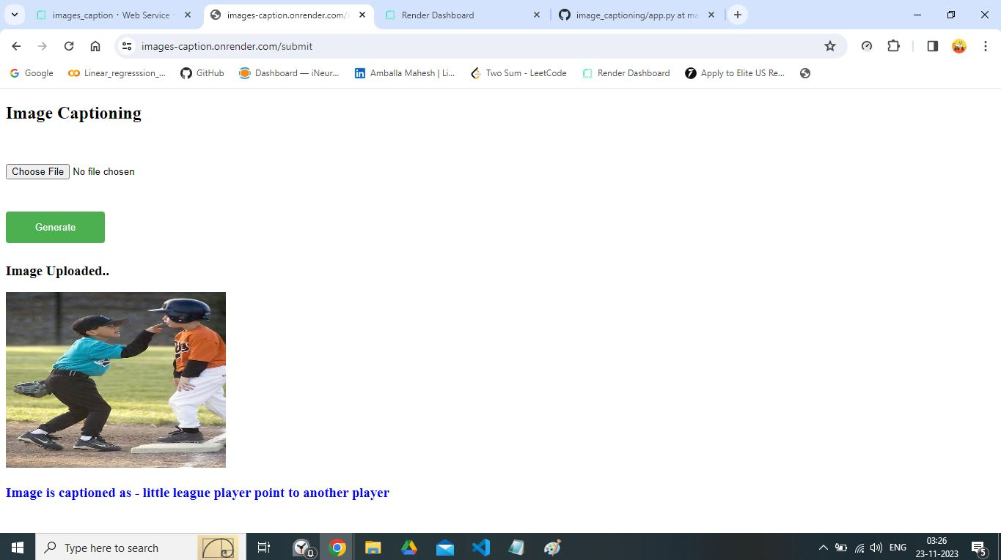

1. Once the captioning is done that site should be ready for another image to upload.



1. Check the logging file whether the logging is active or not.

